

Theresa Leitch

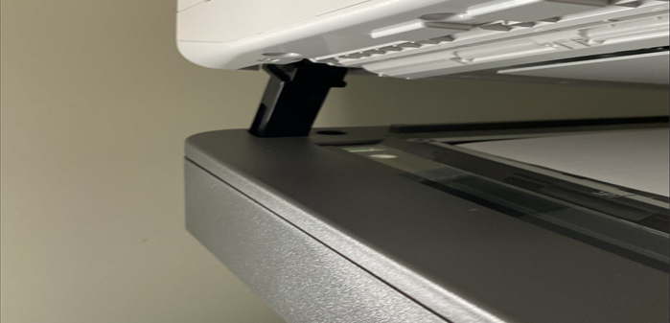
All-In-One (MFP) Copier Catalogue
How It Works

- Why did we create this catalogue? A centrally-sourced catalogue saves you:
  - Time. We have researched the market for appropriate models and pricing.
  - Effort. There’s no need for each library to replicate the acquisition process and, if you use this catalogue when planning to replace your equipment in your budget process, there’s no need for a business case.
  - Money. We negotiated advantageous pricing on four all-in-one models from Ricoh, combining our purchasing power across the network.
- We chose Ricoh because:
  - They have reputable products that meet needs across the network;
  - We were able to negotiate good pricing; and
  - They have sales and support people in every county/district in Ontario.
Why This Catalogue?

MFP* Model | Category | Indicative Price** | CPC*** BW | CPC*** COL | 36-Month Lease | 48-Month Lease | 60-Month Lease
Ricoh IM C401F | A4 Color | $ 4,940.00 | $ 0.0205 | $ 0.1048 | $ 157.24 | $ 124.39 | $ 104.63
Ricoh IM C3510 SD | A3 Color | $ 10,600.00 | $ 0.0120 | $ 0.0851 | $ 332.95 | $ 262.35 | $ 219.74
Ricoh IM 370F | A4 B&W | $ 3,900.00 | $ 0.0221 | - | $ 123.83 | $ 97.89 | $ 82.29
Ricoh IM 3500 | A3 B&W | $ 8,100.00 | $ 0.0132 | - | $ 257.18 | $ 203.31 | $ 170.91

*Multi-Function Printer

**Average configuration
Book copying is feasible on all models
***CPC = Cost per copy (Service Cost)

Available Models and Pricing

Additional Specifications

IM C401F – A4 Colour
- Output Speed (Letter): 45-ppm
- Average Monthly Volume:
2,500 impressions/month
- Weight: 110.2 lbs.
- W × D × H (inches): 19.6 × 22.2 × 23.2
- Book copying available

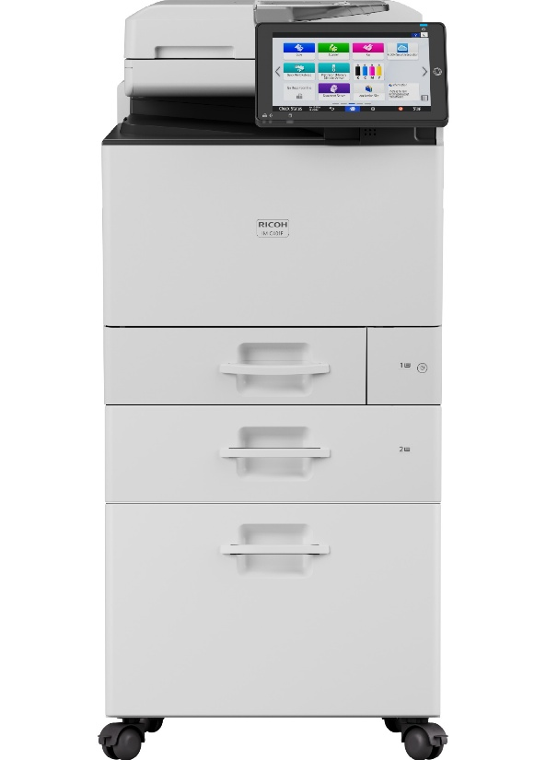

IM C3510 SD – A3 Colour
- Output Speed (Letter): 35-ppm
- Average Monthly Volume:
7,000 impressions/month
- Weight: 224.9 lbs.
- W × D × H (inches): 23.1 × 27.6 × 40.6
- Book copying available

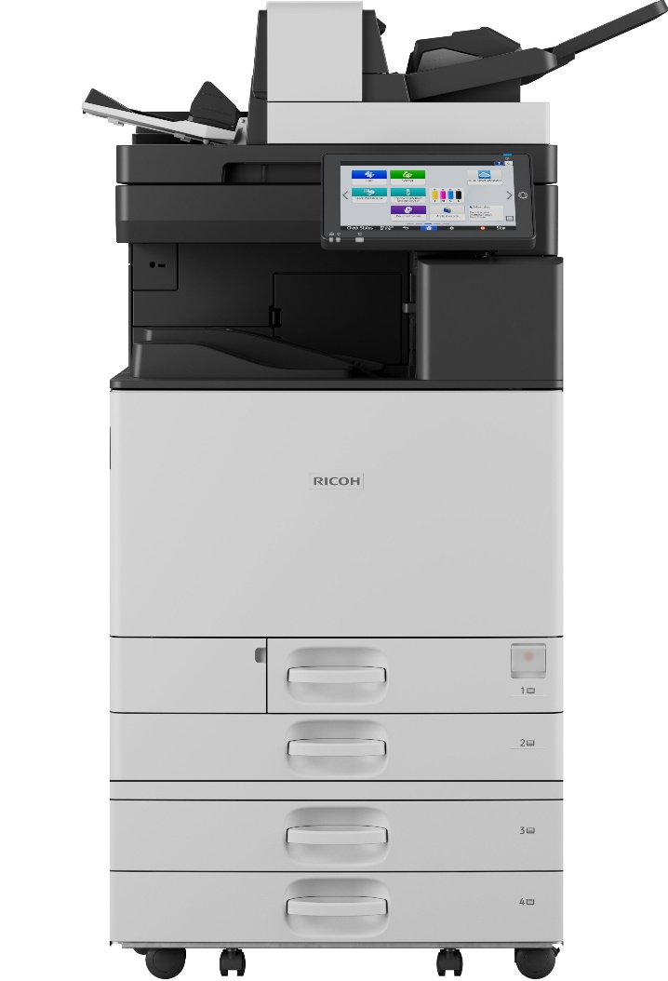

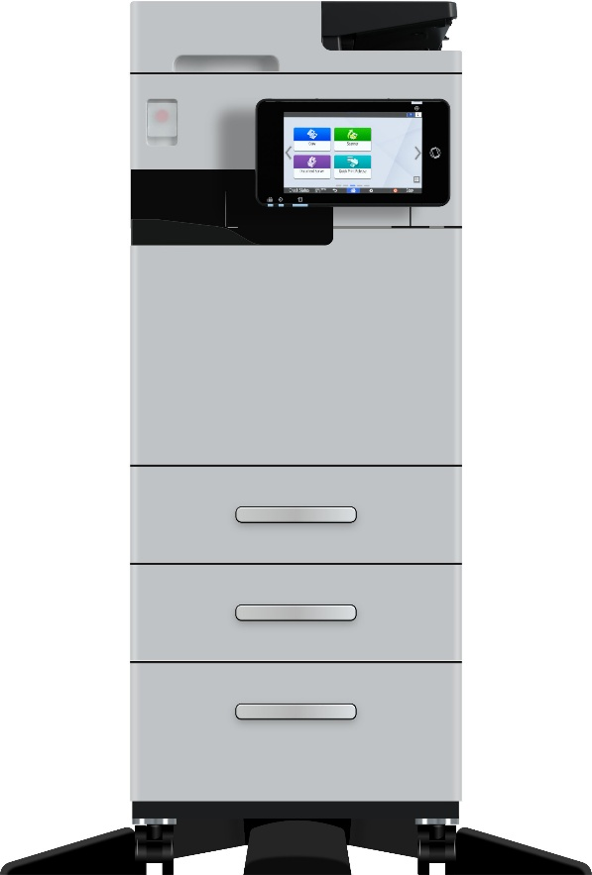

IM 370F – A4 Black & White
- Output Speed (Letter): 37-ppm
- Average Monthly Volume:
2,500 impressions/month
- Weight: 90.2 lbs.
- W × D × H (inches): 14.7 × 19.4 × 25.2
- Book copying available

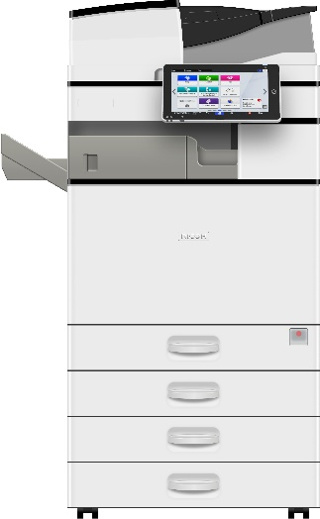
IM 3500 – A3 Black & White
- Output Speed (Letter): 35-ppm
- Average Monthly Volume:
7,000 impressions/month
- Weight: 168.3 lbs.
- W × D × H (inches): 23.1 × 25.7 × 37.9
- Book copying available

More About Ricoh

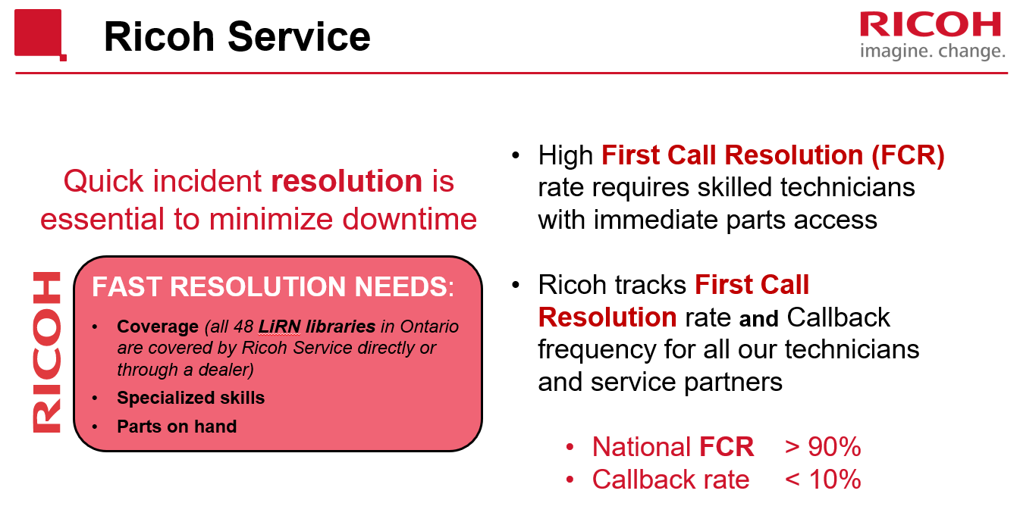

Plan ahead and include in your annual budget.
If your equipment is on its last legs, include replacement costs in your budget for the upcoming year. If you are planning to acquire from this catalogue, no business case is required. Simply include in the budget notes which model you will acquire. If you plan to acquire a different model from Ricoh or a different vendor, a business case setting out the cost and why the catalogue models do not meet your needs is required.

Urgent and unanticipated replacement needs.
Sometimes, your equipment will fail sooner than you expected. If you have an urgent need to replace your copier:
- Contact Theresa (tleitch@lirn.ca) for approval.
- If you are requesting funds for one of the models in this catalogue, simply let us know why you need an urgent replacement (usually because your current machine has broken down).
- If you are requesting funds for a different model from Ricoh or a different vendor, a business case setting out the cost and why the catalogue models do not meet your needs is required.

How to order from Ricoh:
How To Order
- After obtaining any required approval as outlined above:
  - Contact Ricoh Rep.: Ilias Kapodistrias ilias.kapodistrias@ricoh.ca to place your order.
  - Please cc admin@lirn.ca so we can track the usage and performance of our Ricoh contract.

