Theresa Leitch
tleitch@lirn.ca
June 2023 to June 2025
INNOVATION AND EQUITY OF ACCESS TO LEGAL INFORMATION PROJECT



Contents
LiRN Overview 1
Final Activity Report 1
Project Objectives 1
How the Project Unfolded 2
Stream One: Innovation Sandbox 2
Innovation Sandbox Initiatives 3
Stream Two: Equity of Access to Standard Library Collections 5
Chart of books acquired by practice area: 6
Impact 7
Reflections 8
Acknowledgements 9
Final Financial Report 10
Snapshot 10
Details 11
Appendix A: LiRN Strategic Plan 13
Appendix B: Application Information and Assessment Forms 14
Appendix C: Books Purchased Through this Project 15

LiRN Overview
The Legal Information and Resource Network (LiRN) is the central body responsible for administering funding and providing strategic guidance to Ontario’s courthouse law libraries. Our 2026–2030 Strategic Plan (Appendix A) outlines a bold vision to empower courthouse libraries, collaborate across the justice sector, and deliver responsive, high-value legal information services that support both legal professionals and the public.
Mandate: To evolve the provision of law library services and programs for the Ontario county and district law library system in an efficient and cost-effective manner through the management and allocation of grant funding, ongoing assessment of the system and strategic development of appropriate service offerings.
Objectives:
- Facilitating the regulatory mandate to ensure that the public is served by legal professionals with high standards of learning and competence;
- Supporting the ongoing learning and professional development of licensees, with a specific emphasis on the use and application of legal information, legal research and legal training content and activities;
- Establishing a platform that provides access to information for all licensees; and
- Considering the development of supportive legal information services targeted to the needs of users.

Final Activity Report

Project Objectives
The Innovation and Equity of Access to Legal Resources Project, gave law associations the opportunity to pilot their most promising ideas and bring Ontario courthouse library collections up to a common minimum standard. The project launched in 2023 and concluded June 2025.
The objective was to:
- Promote access to innovation through an Innovation Sandbox that allowed libraries to test new technology, and
- Increase equity of access to key legal resources across the province by improving collections to a minimum standard and growing e-LiRN, our suite of electronic research databases.

Stream One: Innovation Sandbox
The Innovation Sandbox was an opportunity for libraries to experiment with ways to expand the traditional courthouse library service model. Network libraries were able to execute their ideas on how to provide library services.
Courthouse libraries were invited to propose ideas that allowed them to experiment with and pilot new technologies, equipment, and service models.
The Innovation Sandbox received 28 applications. Of these, one was not approved as it was aimed at the applying association’s members only and did not fit within the aims of the project. Another was not approved as it was uncosted and of too large a scope for this project.
Innovation Sandbox Initiatives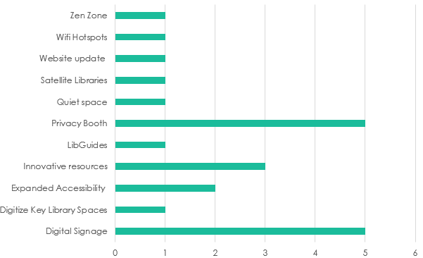
Key details about several successful projects are outlined below:
- The Peel Law Association introduced a new and higher bar for accessibility in Ontario’s law libraries by implementing an Expanded Accessibility Duo. These are cutting-edge tools for library patrons with visual and hearing impairments. Similarly, the Dufferin Law Association is now providing hearing assistive devices.
- The Dufferin Law Association has also created a “Zen Zone” for their users, and the Algoma Law Association is implementing a “Quiet Space”. These were modeled after a pre-Innovation Sandbox innovation created by the Peel Law Association called the “Slow Zone.” These are in-library spaces for library users who need somewhere to manage being overwhelmed, nurse, pray, and more.
- Several associations have installed or are installing privacy booths, giving library users a quiet place to take calls, attend virtual hearings, and even meet with clients. This resource is essential for sole and small-firm practitioners who may not have other convenient options for confidential office space. These include:
  - Dufferin Law Association
  - Halton County Law Association (2)
  - Hamilton Law Association Library
  - Stormont, Dundas & Glengarry Law Association
- The Waterloo Region Law Association added 2 digital signs to keep library users up-to-date with important information. After a successful pilot in Waterloo, other associations, including the Brant Law Association, Dufferin Law Association, and Lambton Law Association will also be implementing digital signage.
- The Toronto Lawyers Association (TLA) is piloting Pleadings, Motions & Facta (2 years) from LexisNexis, an exclusive collection of court documents to use as precedents. This has led to other associations requesting operational funding to acquire this resource.
- The TLA is also piloting IRIS (Insolvency and Restructuring Intelligent Search), an AI powered, comprehensive, and fully searchable database of insolvency court documents, pleadings, reports, and more.
- The Dufferin Law Association added Wi-Fi hotspots to their library, as courthouse users were often unable to access Wi-Fi on premises.
- LibGuides is content management and curation platform that allows libraries to create curated guides to help patrons start library research and reuse guides from their library of over 900,000 existing guides. They can highlight and promote resources and services available at their local courthouse library. The Renfrew County Law Association and the Waterloo Region Law Association both acquired LibGuides through this project.
- The Hamilton Law Association Library is improving their digital infrastructure to allow accessible hybrid programs and interactive library training under the Innovation Stream.
- The Peterborough Law Association is upgrading their library website to attract more users and to transmit information to them more efficiently.
- The Stormont, Dundas & Glengarry Law Association requested funding to improve their satellite libraries. They cover a large geographic area, and adding computer equipment, and occasional librarian attendance will better serve library users in remote parts of their county.
We also worked on network-wide innovation projects including:
- LibAnswers with Lib Chat. This multi-platform communication system allows us to create custom FAQs while the LibChat feature gives end users the ability to contact a librarian for assistance during regular business hours. While we still believe strongly in this project, we did encounter unexpected hurdles and delays, and intend to revive the project in 2026.
- Working with a marketing firm to expand our reach. We contracted with AMP Consulting on a pilot basis to create a newsletter and assist with social media posting to advertise the work LiRN and courthouse libraries are doing. We are now up to 298 subscribers, a number that continues to grow. We have strong open rates, averaging around half of recipients (most newsletters have an open rate of 15 – 25%).
- We created a Library Use Protocol setting out basic expectations for behaviour in courthouse libraries. The idea for this came out at a section of our annual conference devoted to Innovation Sandbox knowledge sharing and idea generation.

Stream Two: Equity of Access to Standard Library Collections
This project stream addresses acquisition needs in both print and electronic resources to allow lawyers across Ontario to access the critical resources required to maintain professional competence and meet the public’s need for effective legal services from anywhere in the province.
This stream added 629 books to the shelves of Ontario courthouse libraries and allowed LiRN to acquire rangefindr.ca for e-LiRN. Please see Appendix C for a sample of books acquired through this project.
Fourteen libraries submitted requests, some at the specific request of our Roving Librarian to address collection issues, and most requests were able to be approved. The majority of acquisitions were in Criminal Law, followed by Civil Procedure, Wills, Estates & Trusts Law, Family Law and General practice. More details can be seen in the chart at the end of this section.
Libraries were provided with labels identifying acquisitions that were funded by the Foundation, as can be seen in the pictures included in Appendix B.
For year two, we invested in a pilot of rangefindr.ca. The pilot runs till December 2026. We are encouraged by the results.
rangefindr.ca is a tool to help lawyers and judges find criminal sentencing ranges in minutes instead of hours. Click a few tags that describe the kinds of cases you’re looking for — such as assault cases where the accused is a first offender — and rangefindr.ca tells you what sentences were imposed in those cases. One more click and you can review the judgments themselves. Remote access for all Ontario lawyers has been available since September 1, 2024 through this project.

Chart of books acquired by practice area:
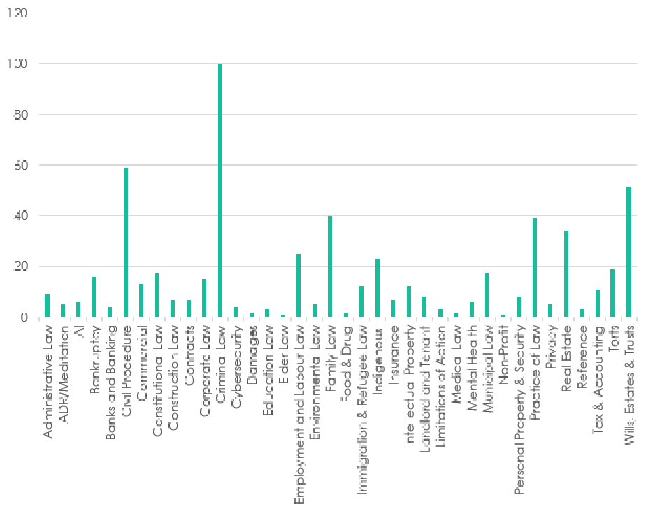

Impact
This project had a significant and far-reaching impact.
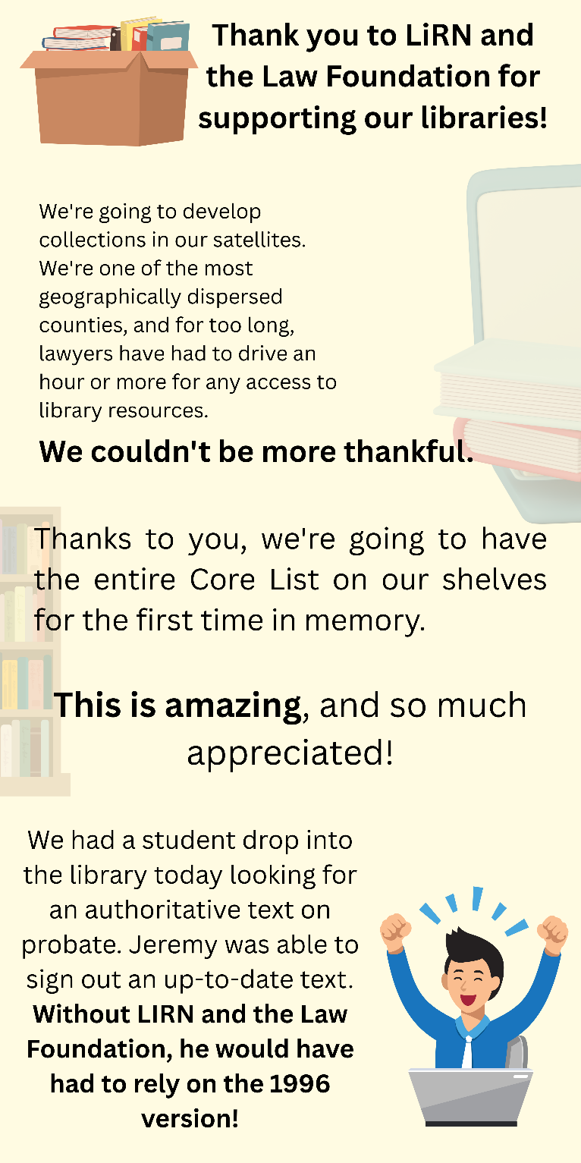
Courthouse libraries were empowered to launch innovative initiatives and enhance their collections. The most immediate beneficiaries were library users—primarily lawyers—who gained access to more comprehensive and up-to-date legal resources. Ultimately, however, it is their clients who benefit most, receiving better-informed and more effective legal counsel.
The impact is especially notable in criminal law. With the remote availability of rangefindr.ca, a key tool for sentencing research, and the high acquisition of criminal law materials in print acquisitions, individuals seeking legal assistance in criminal matters have improved representation.
As described above, we did significant outreach to the individual law associations that operate courthouse libraries to boost participation. We promoted the project in our newsletter, on our website, in conferences as speakers and in vendor halls, and one-on-one. More information can be found in the acknowledgement section.

Reflections
We are pleased with the many successes of this project, as outlined above. It has been a valuable learning experience, both in terms of what we achieved and what we discovered along the way.
One key insight was recognizing the varying levels of infrastructure and readiness across courthouse libraries. In some cases, the addition of Wi-Fi was considered a major innovation, which highlighted how ambitious our initial expectations were. We had envisioned a large-scale initiative that would require dedicated project management support, but the realities on the ground suggested a more incremental approach would have been more appropriate.
A significant challenge arose during the attempted implementation of the LibAnswers with LibChat tool. This platform was designed to provide custom FAQs and real-time chat support from librarians, addressing a widely acknowledged issue: the lack of equitable access to librarian assistance, especially in smaller counties and districts where libraries operate on a part-time basis. There was strong consensus across the network that this tool could offer an elegant and effective solution.
However, the decentralized nature of our network—comprising 48 independently operated libraries under separate law associations—posed a major obstacle. Disagreements emerged around staffing the chat line, particularly regarding volunteer qualifications. Larger libraries, which were best positioned to supply qualified volunteers, expressed concerns about maintaining standards and ultimately indicated they lacked the capacity to participate, even on a pilot basis.
We engaged an external consultant to help navigate the impasse. Through this process, we concluded that the most sustainable solution would be for LiRN to centrally hire a law librarian on contract for the duration of the pilot. This individual would be responsible for implementing the LibAnswers with LibChat tool and developing centralized LibGuides, as referenced earlier. Unfortunately, this conclusion was reached too late to be executed within the timeline of this project.
Despite these challenges, the project has strengthened our understanding of the structural and political complexities within our network. It has also clarified the importance of centralized support for scalable solutions. These insights will inform our future initiatives and help us better align our goals with the operational realities of our member libraries.
The project also fostered stronger relationships with the funded libraries, building trust across the network and contributing to smoother collaboration—all of which ultimately benefit library users and their clients.

Appendix A: LiRN Strategic Plan

Appendix B: Books Purchased Through this Project
Small sample of books purchased through The Law Foundation Grant

