
Computers in Libraries 2024 (Washington DC)

The multifaceted program is designed to meet the needs of librarians, community and information managers, IT and systems professionals, e-resource managers, researchers, webmasters and web managers, archivists, content and museum curators, digital strategists, and information specialists. The focus of the conference is on emerging and leading-edge technology that allows us to engage with, and bring strategic value to, our user communities.
Over 700 delegates, 28 from Canada and 12 from UK and Netherlands.
NOTE: The cost to attend this conference was not substantially more expensive than attending CALL when you add up hotel, registration, and flights. It was about $ 500 more expensive than CALL. I brought my laptop to capture as much information as I could. I met several legal librarians who also attended. Also helpful to take photos of key slides that are takeaways. Many others do this as well.
There are 5 Tracks at #CILDC
- Search & Discovery
- Library Systems & Operations
- Communities
- AI Perspectives & Insights
- Preparing for the Future

LINK to ALL PRESENTATIONS at CIL conference
My notes for each presentation start on a new page to help you scroll through. With 5 tracks it was hard to decide which sessions to attend. For each session I have included its number to make it easier to look for their slides.
Vendor Exhibit Hall list

Vendor Idea GO School for Information Programme for Marketing for Information Pros
Topics include: Search, Information Retrieval, Content Management, Content Curation, Records Management, Document Management, Archiving, Social Media, Marketing of Information Services
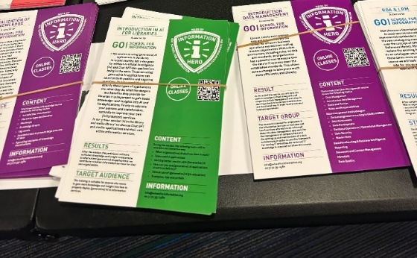
There are 5 Tracks at #CILDC
- Search & Discovery
- Library Systems & Operations
- Communities
- AI Perspectives & Insights
- Preparing for the Future
LINK to ALL PRESENTATIONS at CIL conference

Table of Contents
Computers in Libraries 2024 (Washington DC) 1
Highlights of CIL Conference by Jacquie Fex 3
Keynote: Our Next Reality: AI-Powered Metaverse? 5
Future-Proof Your Library: BIBFRAME & Linked Data 7
A101: SuperSearcher Tips – Mary Ellen Bates 8
C102: Connecting Communities & Information Partnerships 10
B103: Making Online Catalog Dreams Come True! 11
C104: Ecosystem Building for Librarians 12
D105: Library-Powered Innovation 13
Keynote: LC Digital Innovation: Strategy, AI, & Preservation for Community Engagement 14
A201: Revolutionizing Resource Sharing in a Consortium Environment 15
A202: Knowledgebases: Improving Content for Answers 16
B203: Impact & Future of Social Media for Libraries 18
B204: Statewide Ebook Program: Minnesota's Model 20
B205: Transforming Library Spaces: Merging Help & Circ Desks 21
Gameshow Event (tips for running a game using AI) 22
Keynote: Library Futures: AI+, Critical Thinking, & Leadership 23
A301: Tools for Your Wildest Dreams & Library Futures 24
B302: Your Website Can Do More Than You Think 25

Highlights of CIL Conference by Jacquie Fex
- Go Marketing Session for Network – could be a one day session
- Immersive media = the Metaverse – glasses replacing phones in 2032, will need guardrails so we can distinguish between AI targeted advertising and reality
- Floyd explores the evolution of BIBFRAME and FOLIO, the frameworks for organizing and sharing bibliographic data and an open standard that frees the library catalog and allows for the creation of enriched, connected resources.
- A101 Super Searcher session encouraged libraries to learn about AI so that they can be the experts lawyers turn to. Like the early days of Google when lawyers thought they could get rid of Lexis, etc. Any session that features Mary Ellen Bates ATTEND
  - Dare to compare! Knowing how to compete with AI and its advantages/disadvantages
  - Always ask for Sources for ChatGPT- only use AI resources that cite their sources
  - Clients don’t know what to ask for. They ask us for what they think we can do, we need to expand their knowledge of what we can do. Redirect to what’s your underlying need for information?
  - Chatbots don’t do well – don’t notice outliers – less likely to produce the answers. That is where humans /infopros can shine. Chatbots stay in their own field, we don’t, we can think peripherally.
  - Search engines algorithms are changing all the time. Our assumptions must change. Natural language gets better results. Most people speak into search engines now so that has changed them substantially. Use Filter Mode to help improve your results.
  - What is an unexpected development? Ask this question at the end of the search results. Circle back to the client question since we all can get lost on the way
- Creating chatbots, go for the easy wins C102
  - People prefer real people on the other end
  - Generally 80/20 for quick answers versus having to take the chat offline for in depth
- Why build a custom catalogue? Great session with details on pros/cons B103
- Libraries are good at building communities/ecosystems C104
  - Libraries can help raise up the relevant players in a messy ecosystem to help their patrons. Shares details on why libraries are good at this including neutrality, sharing data and analyzing success metrics
- Library ChatBot Aisha – created inhouse at Zayad U in UAE. Details in presentation slides
- Alma Resource Sharing network – OCUL – presented by U of Guelph A201
- Using LibAnswers for FAQs -= good tips in A202
- State of Social Media B203 – Good slides to see the current state of social media right now
  - Fediverse – own moderation rules, cultures users from any server can interact with anyone else, $$$, can hashtag, no algorithmic timeline, manual moderation, Open source
- Statewide ebooks programme B204 – good slides for rollout but primarily Education use
- Keynote Library Futures: AI+, Critical Thinking, & Leadership Dr. Liz Lawley,
  - GenAI tools are like interns
  - You have to give them very clear & detailed instructions
  - You have to check their work carefully
  - They don’t remove the need for expertise, but they do reduce the time spent on tasks
  - Best Prompts – Context window which means it should be one or two paragr. of text
- Rebecca Jones spoke about the need for a vision statement and good tips to develop one A301
  - SWOT – change to TOWS – Do in reverse when strategic planning
- B302 Your website can do more than you think
  - Their My Account
    - Can display what users have signed out
      - Can LIBIB do this as well ?
    - Patrons really like to see where they stand in term of items signed out, on hold
  - ILLs – Options
    - Do you want us to purchase an item? (Not a guarantee stipulated)
    - Shows if the item is purchased and it’s status (On Order / Arrived)
  - Do you want us to borrow this item for you?
  - Allen County Public Library website

Game show: Are you smarter than AI
Tip – when participating – make up a foolish name and not your real one
Tools used:
- Eduology.com/ai-tools – free to use, owned by librarians from libchalk
- Ailab.libchalk.com/gameshow
- Afforia – uploaded Computers in Libraries information
- Chatbase.co – On demand chatbot creation

Keynote: Our Next Reality: AI-Powered Metaverse?

During the last 100 years, technology has changed our world. Within the next decade, it will transform our reality. We are entering a new technological age in which AI and immersive media will transform society at all levels, mediating our lives by altering what we see, hear, and experience. Powered by immersive eyewear and driven by interactive AI agents, this new age of computing has the potential to make our world a magical place where the boundaries between the real and the virtual, the human and the artificial, rapidly fade away. If managed well, this could unleash a new age of abundance. If managed poorly, this technological revolution could easily go astray, deeply compromising our privacy, autonomy, agency, and even our humanity. Hear what our early pioneer of virtual and augmented reality, technologist with more than 300 patents, and CEO of an AI company has to say about our future in the metaverse!

Speaker: Louis Rosenberg, CEO, Unanimous.AI and Author, Our Next Reality: How the AI-Powered Metaverse Will Reshape the World Louis@unanimous.ai
- Past 100 years have changed our world, next one will change our reality
- Our new reality + AI = Our Next Reality – book that was authored by speaker
- Immersive media – e.g. Metaverse coined by Neal Stephenson
- E.g. spatial reality, virtual reality, ETC
- Flat screen to spatial experiences
- Augmented (static screen) to Mixed (Eyewear) to Virtual – eye & hand wear
- Walk down a grocery store aisle and your list pops up identifying things on your list
- Next: Adaptive Interactive Intelligent
- 2032 using mixed reality eye wear will replace our phones
- This Needs Guardrails
- The Metaverse will impact us with deeply human experiences. Remember everything you do in this space is being tracked. They can modify the world around you at their discretion.
- Utopian technology 15 years ago now Dystopian! Destructive to society, no longer the public meeting halls of twitter, etc.
- Metaverse – assumes an advertising business model – like social media but MUCH WORSE
- Optimize Influence in real time
- Track where, who you are with, how long your gaze lingers, monitor facial expressions, vocal inflections, biometrics – how you behave & how you feel while doing it.
- Immersive influence – was the person walking by drinking a Red Bull real or not?
- Access to your data history, likes wants etc. use a voice that you like to influence
- Guardrail: Virtual Product placements should be transparent – look different, identify themselves & that they are promoting things. Special Protections for kids who cannot distinguish yet.
- Regulation will limit but not eliminate the problem
- Need safe & trusted spaces such as libraries- Manipulation free

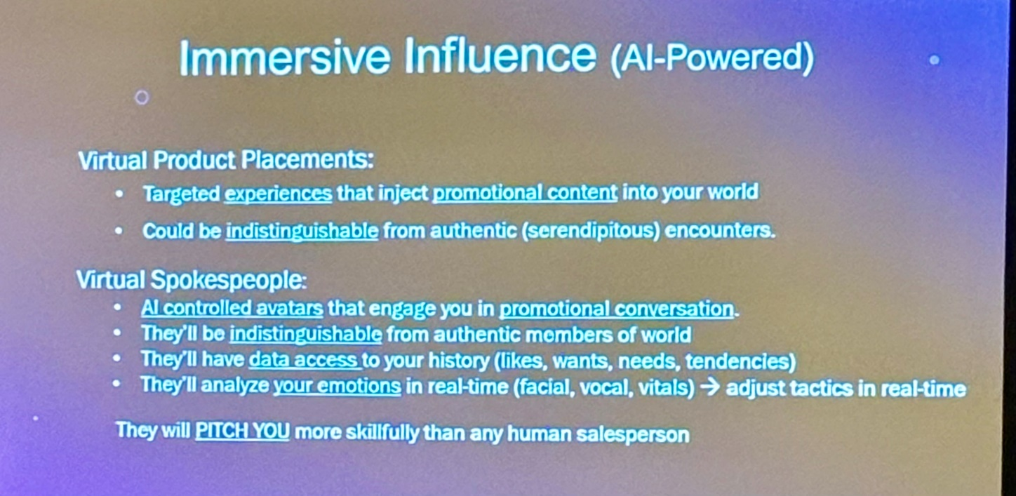

Future-Proof Your Library: BIBFRAME & Linked Data

Floyd explores the evolution of BIBFRAME and FOLIO, the frameworks for organizing and sharing bibliographic data and an open standard that frees the library catalog and allows for the creation of enriched, connected resources. FOLIO is an open-source library services platform with a data model that is designed to work with both electronic and print resources to provide a path from traditional bibliographic tools into the future of BIBFRAME. Hear about the power of using FOLIO and BIBFRAME together to help libraries highlight and expose their collections to users on the open web and how EBSCO is reimagining library cataloging with BIBFRAME and the FOLIO library management system to do so.
Speaker: Chappy Floyd, VP, SaaS Innovation, Corporations & Government, EBSCO
- BibFrame (EBSCO) is an open standard that fees the library catalogue and open access to that rich information, EU Parliament library example used
- Internet Library Open Archive – find this at a library near me
- Unique Identifier – URL Each resource is a link
- Connections made – Bownian movement to Albert Einstein – information overlay
- Library.link open data platform

A101: SuperSearcher Tips – Mary Ellen Bates

Don’t miss one of our most popular sessions! Our knowledgeable speaker is always reinventing and transforming the world of search and delighting customers. Bates is a super searcher, an annual favorite whom attendees flock to hear as she continues to surprise and impress with new strategies, techniques, tips for getting the most out of web research, and making an impact in whatever information community you are affiliated with. The host of Searchers Academy (where she and her colleagues share even more secrets), Bates provides an up-to-the-minute and jam-packed-with-valuable-tools-and-tips talk that’s always a hit! Bates tells us she takes days to research this session, so take advantage of her knowledge, and gather tips and tools to share with others.
Speaker: Mary Ellen Bates, Principal, Bates Information Services, Inc.
- This year, new PCs are going to be AI -enabled. That ubiquitious AI
- Our job is to talking about it in a smart way - like the early days of Google – need to educate lawyers that still have to pay your subscriptions to Lexis …
- Talk about them knowledgably with our user groups
- Which search chatbots are looking at live ones and which are looking at ones from the past
- Dare to compare! Knowing how to compete with AI and its advantages/disadvantages
- what is already out there
- Always ask for Sources for CGPT- only use AI resources that cite their sources
- Bing Chat – get used to asking what sources as part of the prompt – if it can’t – could be hallucinations…
- Elicit.com
  - peer reviewed literature, good for empirical research questions, Good for upload papers for it to summarize, Discover concepts across articles Good for date to compare takes top 5 or 6 articles and summarizes together – good for buzz words, has columns of outputs incl outcome measure – gives an idea that it was on the right track. Nice perspective if new to a topic. List of concepts – list of all the issues generally discussed on a topic. Get the information typography this way.
- Perplexity.ai
  - Summarizes search results, full URLs to sources, trustworthy sources
- Consensus GPT 4-powered sources – yes or no answers
  - Analyzes information & tone, good for an issue that has points of view
- Users Looking for more than just information. Content getting richer like Substack. Clients don’t know what to ask for. They ask us for what they think we can do, we need to expand their knowledge of what we can do. Redirect to what’s your underlying need for information?
- Watch for the “Huh that’s weird” – moment – find less information than expected – new terms or phrase correct? Words like measure can limit your search. Look for peripheral answers
- Chatbots don’t do well – don’t notice outliers – less likely to produce the answers. That is where humans /infopros can shine.
- Search engines algorithms are changing all the time. Our assumptions must change. Natural language gets better results. Most people speak into search engines now so that has changed them substantially. Use Filter Mode to help improve your results. Assume like you have to behave like a regular user to get better results. Purchasing trends 2024 millennials. What are the key purchasing trends of millennials. – better results for the natural language search
- Cross pollinates with inter-disciplinary
- We are competing with chatbots so we need to demonstrate to users our value. Chatbots stay in their own field, we don’t, we can think peripherally.
- What do to when you don’t know what to do
- If it sounds familiar what are my unspoken assumptions. Getting complacent. Use Google search tracking to get better results (then logout) use an alternative search engine. Ask a question like What is one expected development in XYZ?
- Finding AN answer if not THE answer
- What is an unexpected development – good to do for 30 seconds at the end of the search results.
- Circle back to the client question since we all can get lost on the way
- Super Searcher Tricks
- Skip the 1st 10 results from Google – they have been the most- SEO’d
- Stay focused on the Question
- Site – still works on Google and digs deeper into a website than Google scraps: 3 results to 64 results
- Example:
  - Sparktoro.com – what you can do with that information you found. – SEO, audience based research, free limited results but helpful. Where do people in that industry go to look for information.
- Search.brave.com – use goggles to train results
- SearchTweaks.com – helpful for generating ideas to get started

C102: Connecting Communities & Information Partnerships
Imagine that a person walks up to a library reference desk and asks, "How do I get a building permit?" I imagine the reference librarian would look up the answer and point the patron in the right direction. So, what is the difference if this question were to be asked virtually? The Napa County Library has developed a partnership with Napa County to support community members in connecting them to information and resources through managing the website's inline chat software. This session discusses the implementation and workflows to launch an online chat tool on the county website as well as the role this tool took on during declared disasters and the challenges experienced.
Speaker: Meg Ragan, Webmaster, Napa County
- Tasked with connecting community & government
- Napa County has been on fire since 2017
- Web team of 1, no front desk for government in this case municipal
- Took in a lot of typical questions from clients/users to begin
- Get the easy wins
- Librarians can dig deeper and offer other resources the user may not have thought to ask for
- Vendor called Live Person – has auto-canned messages for initial response.
- The fact that they are connecting to a REAL PERSON made a huge difference, esp. for an older population (or legal
- Audience member uses LiBchat (Springshare)– great for providing answers right now!
- Hours chat monitored – during library business hours
- Like Air Traffic Control for the county as a whole. Connecting people with the resources or subject matter that they are thinking.
- Peaks & Pits slide: People really liked a human and not a chatbot, creating new relationship with community, organizational content improvement, enhanced digital UX, cross-functional customer experience (highlight a nearby county library location
- Pits: confusion about why they weren’t dealing with the librarian (county library) that they expected, added customer service library staff, another technology to manage
- Generally 80/20 for quick answers versus having to take the chat offline for in depth responses
- Uses Google Translate for different languages
- Important piece that folks just want to be acknowledged and that they will get a response.
- Always analyze chat for patters and user behaviours
- Focus Groups to identify areas for digital services/resources improvements.
- Review opportunities to improve automation for FAQ, template questions, and more.
- Data tracking and analysis, create new chat channels?
- Complete UX experience with library staff who have related experiences and temperature of the audience.

B103: Making Online Catalog Dreams Come True!
Myers discusses a custom online catalog developed for the Brooklyn Public Library. It includes a walk through the design/UX decisions and functionality unique to its online catalog, including FRBRized results, ebook integration, event integration, online resource integration, and the software's Progressive Web App capability (a web app that can be installed as a mobile app).
Speaker: Cameron Myers, Web Developer, Brooklyn Public Library
- Bklyn Public Library, Cameron Myers
- Why Build a Custom Catalogue?
- Something that meshes the online experience with a catalogue
- Doubles with Event Searches at Library
- Browse Popular Topics – in bubbles across the top
- Tags displayed for users to choose
- Chose booklists, events, Everything, books, age range, ebooks, pages, blogs, websites
- Default sort by Popularity
- Can place holds and know how long waitlist is
- Choose Library to send book to for pickup
- Available now / On Order – great buttons to have
- Format buttons allow easy browsing with new acquisitions or popular items first / Sort by option
- Connect to Overdrive for ebook loaning
- Users can create Lists of books for their own reference, multiple lists for multiple topics like Sentencing, drinking & drinking….
- Allows for Marc Record data as well
- Uses Marc for spell checking / synonyms.
- Client History in case they are trying to remember which book that they used
- Your account so that they can update their preferences
- Self-checkout using a camera to capture the barcode
- Can be used as an App for phones: Mobile Optimized catalogue
- Across the top: Hours of Operation, Location,
- Hard to get search applications to work with MARC records
- Pros & Cons slide – major Con is that there is not one vendor to do this in the marketplace – they used a range of vendors to build what they wanted $$$$, took 9 months and lots of iterations as they sought user-feedback

C104: Ecosystem Building for Librarians
Our speaker is fascinated by how people work together to do the impossible. It’s like a good underdog movie. Solve the climate crisis? We got this. Affordable housing? Yep, we have a plan. Poverty? It's getting better over time. Sweet has to be optimistic because reality would never encourage people to try the truly hard things in life. The truth is that all of these big, pressing problems require a dizzying complex ecosystem of organizations to address the problem. This session talks about how to map ecosystems, break down silos, and get people on the same page through community building and targeted resource sharing and then how to help them navigate those newly established ecosystems. It's not always easy. The world is messy, and people are even messier. But it is possible. Learn how the library can house the right resources to drive innovation and address those massive community problems that dangle precariously over our heads. Take a deep breath. We got this.
Speaker: Amanda Sweet, Technology Innovation Librarian, Nebraska Library Commission
- Explore – where do they fit in the world, what matters enough to take action
- Motivate – library can help motivate (not well explained by speaker)
- Connect – find the right people to connect with….
- Learn
- Future
- Used example of Nebraska firefighters that train use virtual reality and were not communicating with AI Insurance providers, etc., Insurance people not talking to the policy-makers
- Libraryland
  - What is the problem?
  - How is change happening
  - Who are the key players
- Libraries can help raise up the relevant players in a messy ecosystem to help their patrons
- Creating an ecosystem Adapted from The Visible Network
  - Chose a manageable problem
  - Shared understanding of root causes
  - Find ecosystem friendly partners
  - Neutral understanding of government
  - Share data and ideas
  - Determine success metrics
- Problem mapping methods – need a Project Manager on crack (paid, incentive role to keep the project moving forward)
  - Conversation
  - Strategic plans
  - Community leaders
  - Conferences
  - Observation
  - Entrepreneurs
- Map out organizations at different levels (parties involved in the problem)
- UN Slides on The World has Problems “The Global Goals”

D105: Library-Powered Innovation
In November 2022, OpenAI revolutionized AI with ChatGPT and its API, enabling global developers to create new projects. Zayed University Library in the UAE leveraged this to develop a custom library chatbot, with a prototype ready by February 2023. This project, detailed in a June 2023 journal article, became the first documented GPT-based chatbot for academic libraries. Utilizing Python, a vector database, and the LangChain framework, the bot draws on the university library's resources and external tools such as Google and Wikipedia to enhance user interactions. It supports multilingual responses, reduces AI hallucinations, and recently added voice features. This presentation discusses the bot's development, user survey results, and future plans, highlighting its potential to revolutionize library services with personalized, efficient support.
Speakers: Yrjo Lappalainen, Data Services Librarian, Zayed University Library & Learning Commons (United Arab Emirates)
Nikesh Narayanan, Assistant Professor and IT Librarian, Zayed University Library & Learning Commons (United Arab Emirates)
- Zayed University at United Arab Emirates (UAE) – Developing a chatbot for their library called Aisha
- Open AI released CGPT enables developers to us the model at low cost without special hardware
- Developed using Python + Open AI API
- Created Aisha! In Arabic means lively
- CONSULT SLIDES
- Journal of Web Librarianship – article about their work to develop Aisha
- Streamlit for interface – free version, 1 G of memory, likely not enough
- Knowledge database comprised of the following:
  - Website, LibGuides, LibAnswers …
  - Additional tools
    - Google
    - Wikipedia
    - Library catalogue Primo
    - Digital Commons institutional repository
    - Library calendar
    - Google Scholar
    - Calculator
    - Other custom tools
- LangChain Framework – very useful framework! Python.langchain.com
- Langchaindar.com, documentation is lagging behind if available at all since the field is growing so fast!
- https://zu.libguides.com/ai/aisha-chatbot - You can talk to her!
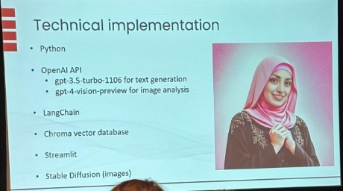

Keynote: LC Digital Innovation: Strategy, AI, & Preservation for Community Engagement
Preserving history and engaging our communities are important parts of our future. Hear about how the Library of Congress is using innovative techniques, such as machine learning for generative bibliographic data and engaging with new communities from leaders in the field. Learn about the direction of digital innovation for the next few years and the library’s strategic plan, lessons learned that will help libraries as they navigate their futures, and areas that libraries can excel in within their communities with respect to AI and technology.
Natalie Buda Smith, Director of Digital Strategy - Library of Congress
Leah Weinryb Groshgal, Senior Program Advisor to the Director, Digital Strategy - Library of Congress
- Digitization is baked into the LofC, founded in 1800, largest library in the world
- 3200 permanent employees, 178 million unique visitors
- A library for all – new strategic plan
  - What do we want to enable
  - What do we want to be visible

- User centric – The Ends – Expand access, Enhance Services
- Org. centric Strengthen capacity, Innovation
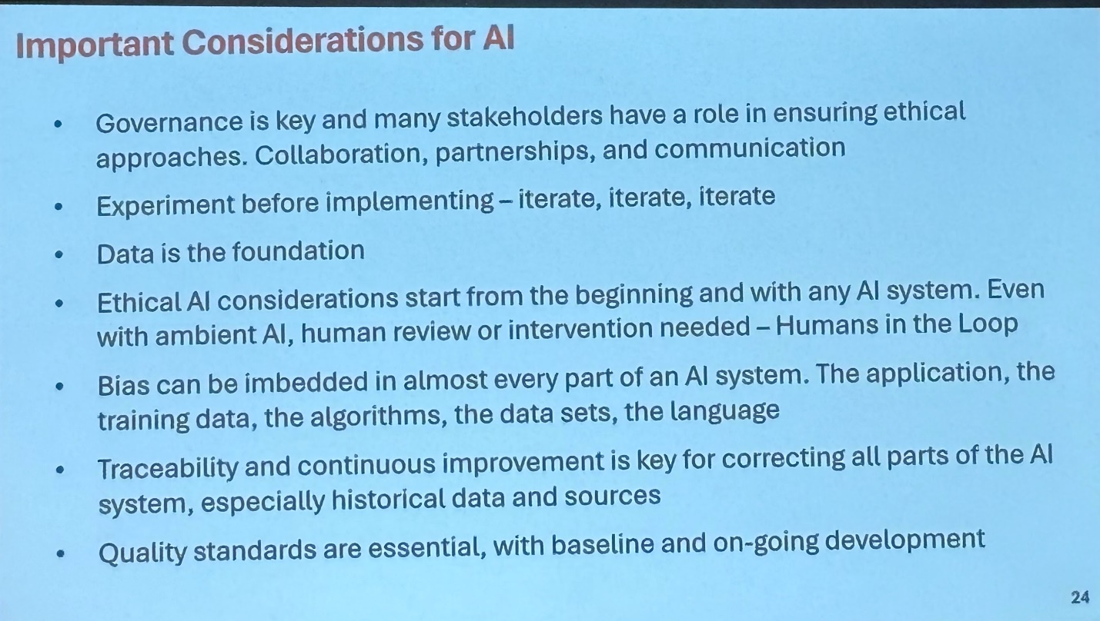

A201: Revolutionizing Resource Sharing in a Consortium Environment
Randy Oldham, Head, Digital Strategy & Technology - University of Guelph
Is your library facing budget cuts to collections and/or services? Are you seeing or expecting an increase in interlibrary loan? Learn how the Ontario Council of University Libraries (OCUL) ventured into the world of Alma/Primo as a consortium of 18 university libraries. Oldham focuses on how Primo/Alma enabled new ways of sharing resources across a consortium, and how it was able to leverage functionality within Alma to revolutionize the way it does resource sharing … slowly.
- U of Guelph speaker – slides very drag show heavy
- Photo of Hearses that used to be used to share books around Guelph
- OCUL Ontario Council of University Libraries
- 2007 Universities Canada wide – Resource sharing agreement, No central office
- RS (Resource Sharing) – cannot own everything.
- Libraries have an ethos of sharing.
- Limited by copyright and licensing restrictions
- Physical shipping costs v. time to digitize – costs to the organization.
- OCUL – VDX software product for ILL doc & request management
- ALMA – has resource sharing out of the box!
  - Network zone that allows you to share with everyone, fulfillment network as well, ILL for inside and outside network (with protocols) Rapido is their “WorldShare”
- Automated Fulfillment Network – share the Network Zone NZ, some in Institution Zone, some Shared Patrons and Shared Polices Only for Physical things.
- Fulfillment Network – only for digital – can interact with any institution that is not part of your network.
- Alma looks for who has it once a request is submitted. Lender controls Policies received.
- Alma Resource Sharing Network – like a phone book and can add institutions.
- To launch across Canada – harmonized fulfillment policies
- Live testing really key during soft launch
- Limitations – can’t move requests to a differ place, fine, or restrict certain user groups within
- Alma does support Email Partners such as law firms, etc, outside of network
- Bonus – ease of discovery meant unused items started circulating again.
- Substantial Increase resources sharing, substantial!

A202: Knowledgebases: Improving Content for Answers
FAQ knowledgebases are common website components that empower users to find answers to frequently asked questions. If designed well, they reduce user frustration and confusion. The LibAnswers FAQs platform enables librarians to easily provide a searchable and browsable knowledgebase for students and community users to access 24/7. Libraries’ usage of this platform rose in importance during the COVID-19 pandemic due to the fluent nature of services and information and user needs for reliable and up-to-date information. Considering a year-long website redesign and the student perceptions survey, a large community college examined the information architecture, user interface, and content of its FAQs site with the aim of improving discoverability and content depth. Pain points identified included inconsistent application of topic categories, ineffective keyword tagging, and an overall disconnect between the redesigned website terminology and organization of the FAQs knowledgebase. In consideration of these barriers, the information architecture of the FAQs site was reimagined to ensure students can efficiently search this knowledgebase and succeed in locating answers to their questions about the Learning Commons resources, services, and related topics. Changes to the FAQs site embraced updates to grouping terminology, revamped strategic keyword application with the aim to improve search relevance rankings using consistent and more descriptive topic labels. It also resulted in better-informed decisions about types of FAQs content for inclusion in the site. This presentation offers practical solutions to improve existing FAQs organizational structures and content to better meet the needs of users. Dr. Michael LaMagna, Information Literacy Program & Library Services Coordinator; Professor of Library Services - Delaware County Community College Andrea Rodgers, Associate Professor, Library Services - Delaware County Community College
- From Delaware County College Library
- LibGuides used for their FAQs Product
- Created a Style Guide for FAQs for consistency
- Inconsistent key work tagging
- Library Services / Workshops/ Faculty Support / Forms moved to task-based structure
- How Do I …? / Get Help with Essentials / Today’s Hours/ Search Requests
- Student Perceptions Survey
- Had a Fake News Topic Guide
- Used an embedded image instead of text-based narrative – very popular from their survey
- Topics & Keywords working together – revised accordingly. Users can browse by Topics
- Hyperlinked and displayed in FAQs
- Can be a filter on search results - see Photo
- 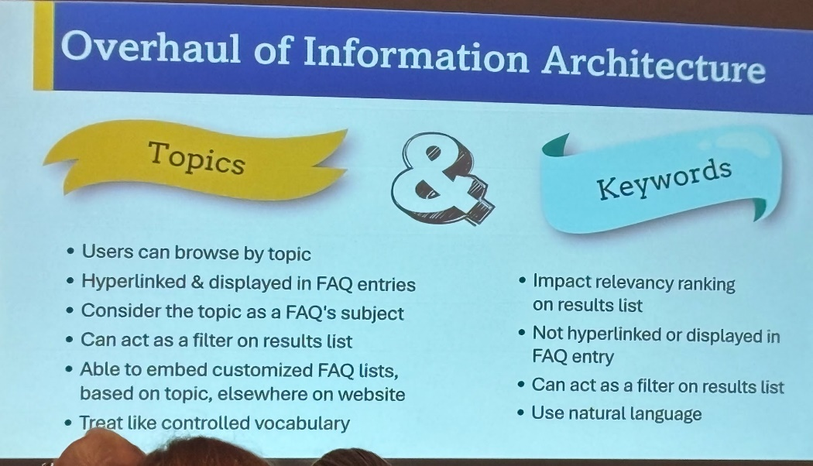
- Went from APA & MLA to CITATIONS and make APA, MLA keywords
- Grey Text prompt in Search box: What do you need help with?
- Created a Topic Cloud for suggestions when asked Do you need more help?
- Consistency where it matters (labels) and flexibility where it doesn’t: keywords for search relevance).
- Regular Query Analysis – helpful to keep on track with what users are looking for

B203: Impact & Future of Social Media for Libraries
In December 2021, Elon Musk made headlines by announcing his intention to buy Twitter for $44 billion, a move that stunned the tech industry and sparked heated debates about the future of the platform. In the months since the acquisition, Now known as X, the platform has undergone significant changes, both in terms of its features and its userbase. DeLooper explores the effects of Musk's purchase on usage through the lens of its effect on his library’s profile and draws lessons about the utility of social media, sharing the challenges of different platforms, and finishes with a discussion about the future of social media. Ferdinand discusses the harnessing of consortial power to rebuild microblogging. Technology providers such as universities, university library systems, and public libraries have an opportunity to build toward a free and open internet by taking on the microblogging mantle, moving away from power-hungry oligarchs and advertising and toward a platform available to everyone. Ferdinand proposes a "microblogging moonshot" where universities and libraries host Mastodon instances for X-like microblogging. Doing so at a mass scale can solve the problem of verification on microblogging services, reduce fake news and other disinformation through open development of the platform, and harness moderation tools at scale through investing in existing social media teams. It can create a new, near-real time alerting service through open APIs, the likes of which X can no longer be depended upon to provide. It can even replace the valuable tool of conference posting! by treating microblogging as a utility and building out a worldwide infrastructure to support it. Hear his ideas around an opportunity to create a tremendous good for our communities. Khatoon looks at social media and libraries connecting people across the globe with unprecedented ease. She shares examples of how social media tools for individuals, communities, organizations, and businesses disseminate information, engage with audiences, and promote services. She shares how libraries are using social media platforms as avenues for promoting their collections, engaging with their community, and increasing awareness about their services. John DeLooper, Web Services - Online Learning Librarian - Lehman College – CUNY Luke Ferdinand, Technology Support Services Manager, University Library System - University of Pittsburgh
- Luke Ferdinand – U of Pitt – Detailed slides available
- Take back social media from corporations and make it a utility and less than selling people’s attention to the highest bidder
- Twitter turning into a toxic ghost town. By taking away authentication, it took away the way to view an authority’s posts. People have gone to Signal, Discord, Whats App, Insta, Threads, ETC
- Twitter results have become unreliable. Verifications are for sale now.
- Elon fired so many employees and turned it into a misinformation farm
- Twitter was helpful when new org. couldn’t make it to a location. Verified news org. won’t pay to be verified so we have lost that information source.
- Corp Social – FB & IG & Threads – they won’t use Tiktok or X now
- Mastadon – very much the underdog in this conversation, has verifications.
- Fediverse – own moderation rules, cultures users from any server can interact with anyone else, $$$, can hashtag, no algorithmic timeline, manual moderation, Open source
- 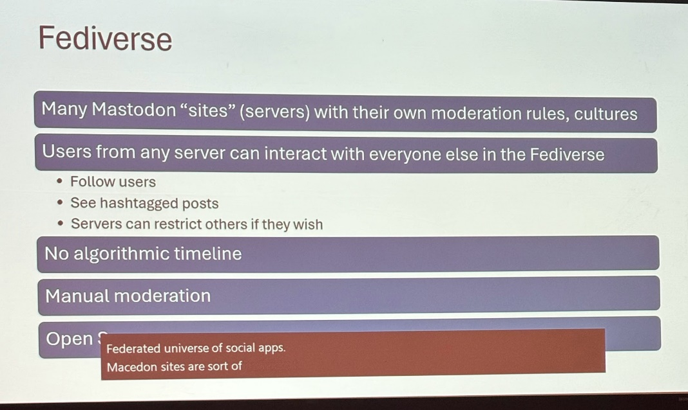
- Activity Pub – used by Mastadon – allows users on different platforms to send emails. Not exclusive for example if Gmail limited itself to only to Gmail users
- Mastodon allows you to self verify to domains you own.
- Mastodon.Social how to get verified: URL in slide

Future of Social Media John Looper at Lehman College
- Why do we use social media? Encourage the use of library services, events, answer questions from patrons
- Twitter data has become unreliable in terms of users/usage. They checked and their analytics did not correspond to what they actually posted, not captured. Similar issues with FB analytics too.
- Video is the way to go but that is a lot HARDER to do!
Note look for Entrepreneur slides – using Snake Oil game (Mentorship idea since you have to sell your idea to the others playing)
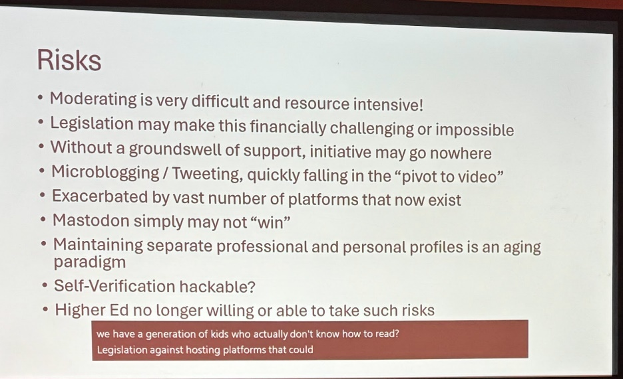

B204: Statewide Ebook Program: Minnesota's Model
Ebooks Minnesota, the Minnesota statewide ebook program, has been around for almost 8 years. Its mission and scope have changed slightly since inception, as well as the platform, but the collection continues to grow with a focus on unlimited simultaneous access. While titles in the collection might not be the newest bestsellers, schools in the state are heavy users of this service with the addition of the Minnesota Youth Reading Award-nominated books. In this session, Staats discusses the history, funding, collection development, and issues around offering almost 10,000 ebooks statewide to Minnesota residents. Beth Staats, Outreach & Instruction Librarian - Minitex, University of Minnesota
- Very unique, not many states have this.
- Minitex.umn.edu – located at U of Minn Library and therefore state-funded
- Connected Libraries. Empowered Communities. Enriched Lives
- License and administer Ebsco & Gale
- Use BiblioBoard platform
- Access: GeoLocation – if in Minn you can access it. Occasionally issues but minor
- eBooksMN.org
- focused on Minn-based/authored books. George Floyd murder & Covid expanded interest!
- Simultaneous access so good for classroom use
- People really appreciated the unlimited access model
- Difficulty navigating / understanding scope of collection
- Proposals for new platform were evaluated on
  - Company profile, experience, references.
  - Ability to meet requirements such as barrier-free access, geo-location (no library card or user name) , materials that were popular with users
- Chose MackinVIA – a Minn company
  - High quality metadataw and marc records
  - Aligned with requirements and attributes
  - Willing to work with publishers
  - Free hosting platform designed for schools
  - Digital content management system,
  - Can be used on desktops, laptops, mobile devices
  - Allows backpack accounts for checkouts, downloads, notes and favourites
Already this year at 200,000 views Graphic novels hugely popular
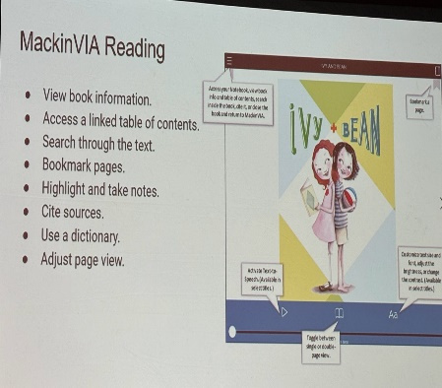
Thought: what about access for lawyers who are out of the province if geo-locator
Has SEARCH box to search the contents of the book
Can change the font
Can change the voice of the reader
Can download for offline reading

B205: Transforming Library Spaces: Merging Help & Circ Desks

Many academic institutions have paired their library and technology support services into one physical space. In fall 2022, the ITS Help Desk at Union College moved from its departmental office on campus to the Schaffer Library Circulation Desk. Hathaway explores the factors motivating this decision, considerations for the move, implementation, and the impact on student success one year later.
Speaker:
Amy Hathaway, Head of Access Services, Schaffer Library, Union College

- Mostly a description of why they decided to do it due to real estate of how much space the circulation desk was taking and integrating themselves where their users are.
- Lots of details on the layout and the steps that they took.
- Students really liked the change
- More dynamic interactions are occurring
- Location
  - Central service point
  - Greater visibility
  - Closer to point of need
- User Experience
  - More consistent service
  - Unified experience
  - Less ping-ponging
- Customer Service
  - Open, Inviting space
  - Self-navigating options
- Staff training
  - Enhanced knowledge base
  - Cross-training
  - Integrated student workforce

Gameshow Event (tips for running a game using AI)
Are You Smarter Than an AI Game Show
Brian Pichman, Director of Strategic Innovation - Evolve Project
Get ready for an electrifying session that takes the classic TV game show Are You Smarter Than a 5th Grader? to a whole new level! In this exciting twist, we’ll explore the fascinating world of Artificial Intelligence and pit our wits against the power of machine learning. Join us as we embark on an adventure where human intelligence goes head-to-head with cutting-edge AI algorithms in a battle of brains. We look at AI's impact on libraries, education, and information access, all while having some educational fun. We examine how AI complements the invaluable role of librarians and the library community. It's a contest of knowledge, strategy, and quick thinking as we challenge our understanding of what it means to be "smarter."
Tip – when participating – make up a foolish name and not your real one
Tools used:
- Eduology.com/ai-tools – free to use, owned by librarians from libchalk
- Ailab.libchalk.com/gameshow
- Afforia – uploaded Computers in Libraries information
- Chatbase.co – On demand chatbot creation

Keynote: Library Futures: AI+, Critical Thinking, & Leadership
Dr. Liz Lawley, Professor, School of Interactive Games & Media - Rochester Institute of Technology
Lawley, professor of interactive games and media, calls generative AI the most influential technology she has ever seen as a teacher—even more significant than the internet, due to the pace of change. As an early gamer, internet researcher, librarian, and speaker at Internet Librarian, she has the perspective to reflect on where our libraries could, and perhaps should, go as they travel boldly into the future. At the top of the list: critical thinking and leadership for libraries. Be inspired, excited, and filled with insights from our speaker as she discusses library futures in a fast-changing AI world.
- ChatGPT has been around since 2018
- Made more accessible and in April 2024 (graph in slides) it has reached 1.5 billion hits
- Large Language Models (LLM) can take several queries - Good one is CLAUDE
- AI Generator for Images – Dall-E3
- Code generator is like having a real smart colleague
  - Amazon Code Whisperer
- Need to know how to code to know what questions to ask, can make mistakes
- GenAI tools are like interns
  - You have to give them very clear & detailed instructions
  - You have to check their work carefully
  - They don’t remove the need for expertise – but they, do reduce the time spent on tasks
- Research Topics – Slide
- Model Transparency – called Huggy Face
- Alignment – takes fine tuning
  - Example of lot of work is done in Nigeria since they speak excellent English but that is different than our world
- Best Prompts – Context window which means it should be one or two paragraphs of text
- Better than Zero Shot
- Source to read regularly on AI developments
  - Ethan Mollick from Wharton – One Useful Thing (free to subscribe)
- We have to learn how to prompt like we learned how to use Boolean search queries
- AI can be good for marketing, launch a product
- MS Pilot is worth paying for. Builds generative AI tools into Apps
  - Make a bio from a resume
- Negatives – can LLM be too big
- Environmental aspects of these tools (bitcoin mining & electricity) and HR Impacts
- Guardrails needed in AI
- C++ Code assumes you are under 18, not code risks
- Copyright and Ownership - AI does not own anything it generates
- Adobe Firefly – targets businesses – Only stock images used
- AI Tools & Resources are a new kind of Information Literacy
- More Tools
  - Eduology.com/ai-tools – free to use, owned by librarians from libchalk
  - Ailab.libchalk.com/gameshow

A301: Tools for Your Wildest Dreams & Library Futures

This session shares the Singapore National Library’s ‘What If’ scenarios for planning; Dysart provides a demo of ‘Standing in the Future’ and shares Arnold Schwarzenegger’s tools for life, including clear visions, never thinking small (confidence), and breaking your mirrors. Snowden shares tips on a new technique, future backwards, which was developed as a planning support method, a side-casting technique. It exposes a large number of perspectives that a group can take on any given issue or theme at a single point in time. Get lots of tips and ideas to support the plans for your library as it navigates and plans for the future.
Speakers:
Jane Dysart, Curator of Curiosity, Dysart & Jones Associates, Canada
Dave Snowden, The Cynefin Company, Book: Cognitive Edge
Rebecca Jones, Director, LLEAD Institute and Partner Emeritus, Dysart & Jones Associates
RJ presented. She recommends Dave Snowden if you even need help putting together a vision statement for a large company. Jane Dysart is very ILL and could not attend.
- Need a vision statement to implement a plan – Vision Schmision
- Only by clearly envisioning the details of our desired future can we effectively plan & Implement that plan to realize our future
- 3 Critical Factors of Success
  - Detailed description of where you are headed
  - Candid Assessment of current situation
    - Stats, Budget, staffing
  - Diverse, Competent perspectives – may need to be a PM
- Do not do a Needs Assessment – go talk to Stakeholders & broader community
  - Talk to who is NOT using your services
- How will we be sustainable in the future?
- Who – the market you serve (not who You are)
- What – the services you offer
- Appreciative Inquiry
- Define – Discover – Dream – Design – Deploy – in a circle to keep yourself current
- Future Backwards – good slide by Dave Snowden
  - Define Current State in 3 statements
    - Envision details of a Utopian future
    - Envision details of Dystopian future
    - Identify steps that led to Utopia, backwards, What had to occur just before that?
    - Map it backwards
    - Reflect & question
- University Libraries used to be seen as the heart of the institution – not anymore
  - SWOT – Change to TOWS Do in reverse
    - Threats
    - Opportunities
    - Weaknesses
    - Strengths

B302: Your Website Can Do More Than You Think

A website is useful if it empowers users to find and accomplish what they need to do. As libraries, we pride ourselves on helping the people we serve explore and find the information they want. Because libraries serve a multitude of people with different needs and demands, figuring out the magic formula to designing a website delivering efficiency and satisfaction is a huge challenge. As our speakers took on their most recent website redesign, they challenged themselves to take a fresh look at the site through the eyes of their visitors. In this presentation, they share their process, from assessing the former website from a user’s perspective to their challenging internal conversations and questions to the final decisions, which led to the new website’s design and functionality. Through website analytics; staff input; collaborative and forward-thinking public services, IT, and marketing teams; and a partnership with an outside partner, the website was overhauled, setting the site up to be a vital communications and marketing channel for the public. It’s true: Your library website can do more than you think!
Speakers:
Kim Bolan, Chief Operating Officer, Allen County Public Library
Aja Michael-Keller, Director, Communications, Allen County Public Library
Jeff Garver, Digital Communications Specialist, Allen County Public Library

- Assess & Plan
- Choose a Tool
- Build & Test
- Maintain & Improve
- Methods: Staff Survey, Patron Feedback, Website analytics
- PATRON FIRST DESIGN – Discoverability
- Moved to Polaris for ILS
- Moved to Innovative (Clairvate) for website
- Web count = Door count – almost the same nowadays
- This has been a very worthwhile investment of patron-first design
- When designing – very important what appears
- Above the Fold
- Reduce use of library jargon
- Call to Action on all pages
- Their My Account
  - Can display what users have signed out
    - Can LIBIB do this as well ?
  - Patrons really like to see where they stand in term of items signed out, on hold
- ILLs – Options
  - Do you want us to purchase an item? (Not a guarantee stipulated)
    - Shows if the item is purchased and it’s status (On Order / Arrived)
  - Do you want us to borrow this item for you?
- Allen County Public Library website

END of NOTES

